**Step 1: Launch an EC2 Instance in the US-East-1 (N. Virginia) Region**

1. **Log in to AWS Management Console:**
   * Go to the AWS Management Console at [AWS Console](https://aws.amazon.com/console/).
   * Sign in with your AWS credentials.
2. **Navigate to EC2 Dashboard:**
   * In the AWS Management Console, type "EC2" in the search bar and select EC2 to navigate to the EC2 Dashboard.
3. **Launch an Instance:**
   * Click on the "Launch Instance" button.



* + **Choose an Amazon Machine Image (AMI):**
    - Select "Ubuntu Server 20.04 LTS (HVM) SSD Volume Type" or a suitable Linux AMI for your use case.

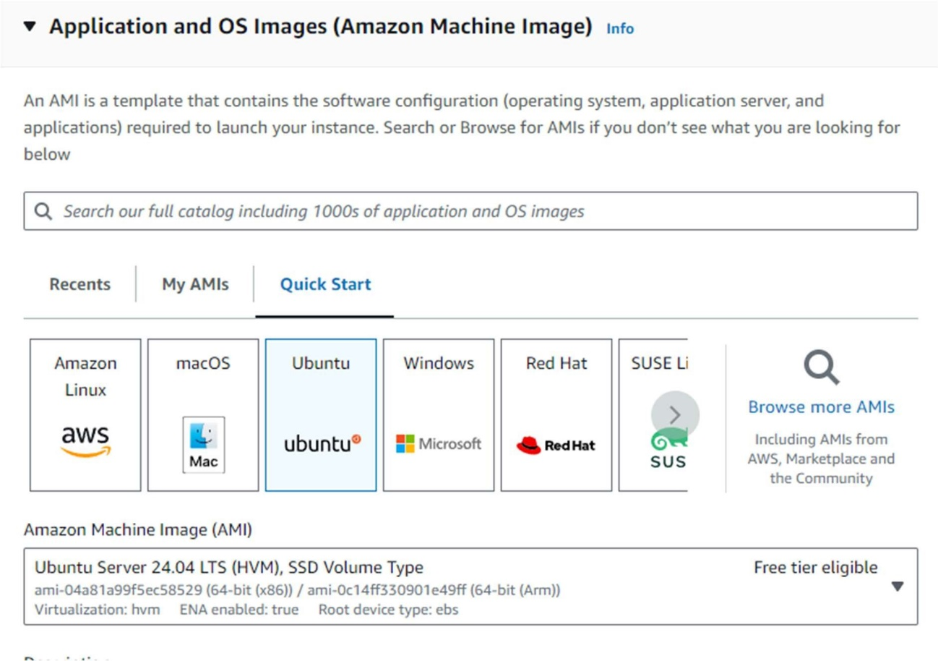

* + **Choose an Instance Type:**
    - Select t2.micro (eligible for the free tier).

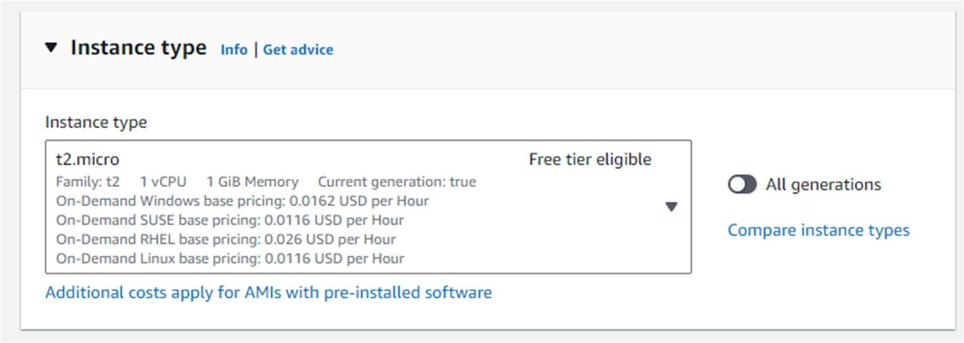

* + **Configure Instance:**
    - Select an existing key pair or create a new one.
    - Network: Choose the default VPC.
    - Subnet: Choose a subnet in the US-East-1 (N. Virginia) region.
    - Enable Auto-assign Public IP.
  + **Add Storage:** Keep the default settings.
  + **Add Tags:** Add a tag to identify your instance (e.g., Key: Name, Value: Nginx).
  + **Review and Launch:** Review your instance settings and click "Launch".

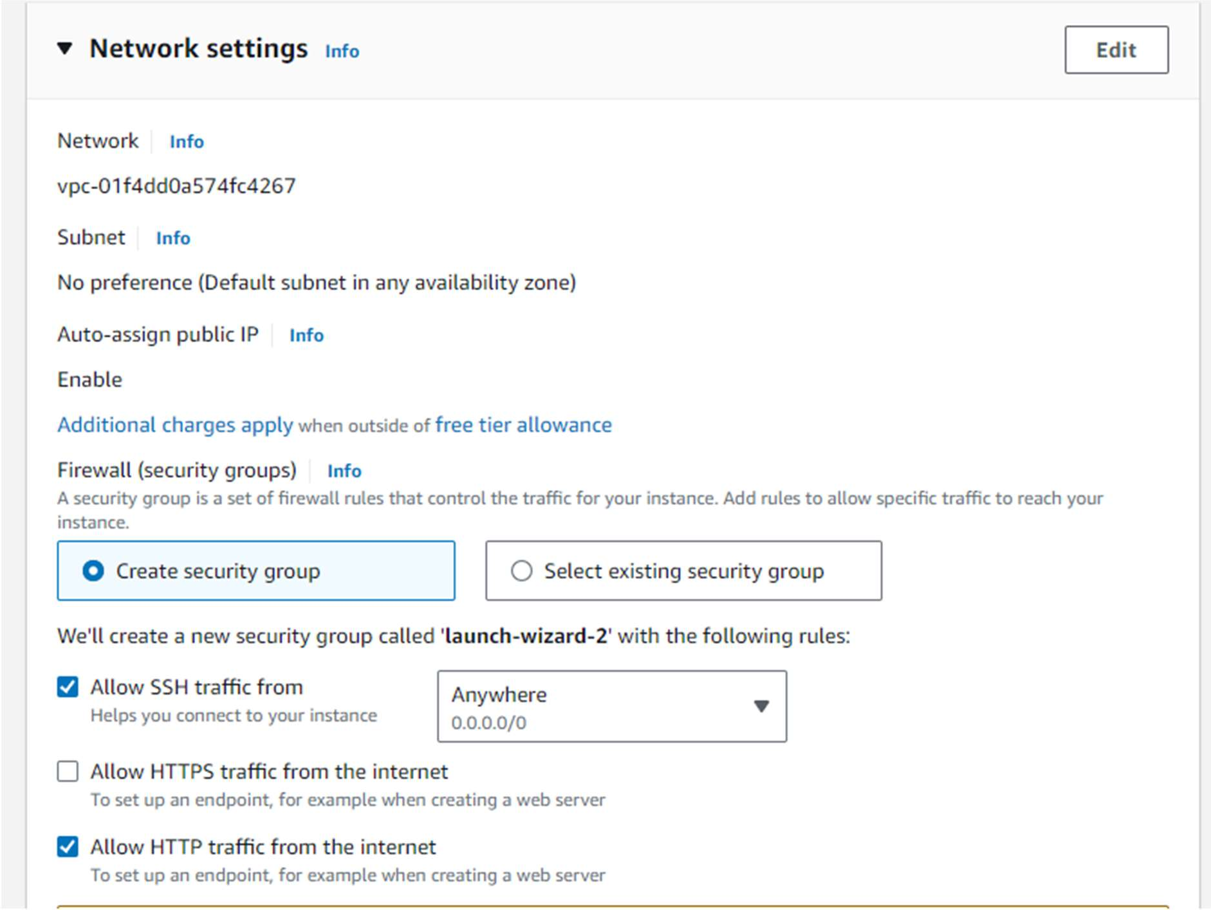

**Step 2: Replicate the Instance in the US-West-2 (Oregon) Region**

1. **Create an AMI:**
   * After your instance is up and running in US-East-1, go to the EC2 Dashboard, right-click on the instance, and select "Create Image".
   * Specify details and create the AMI.

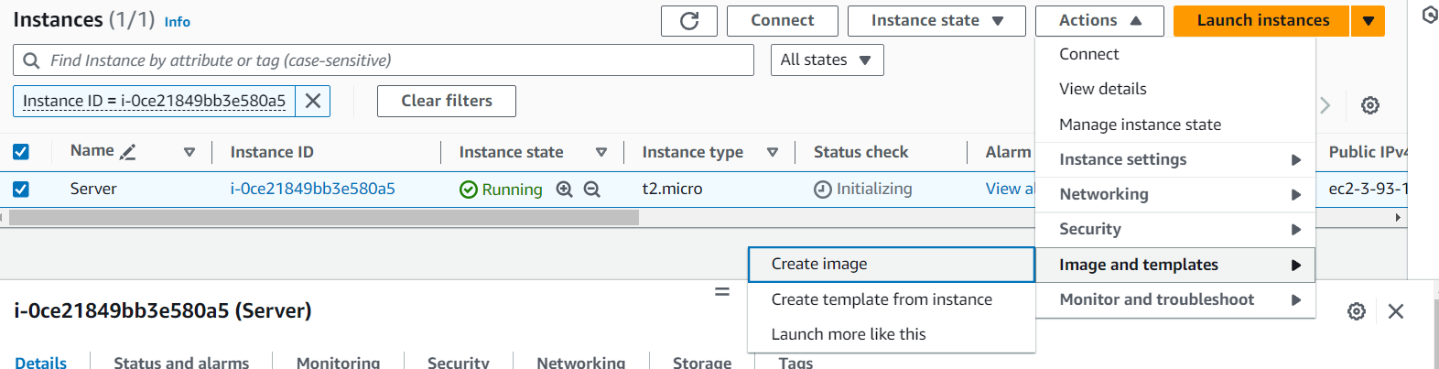

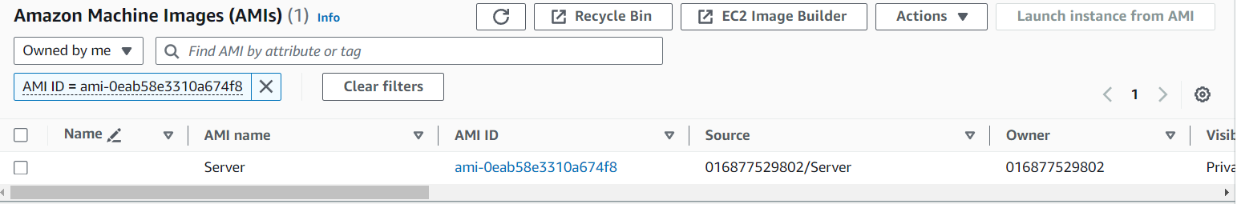

1. **Copy the AMI to US-West-2:**
   * In the AMI section, select the newly created AMI.

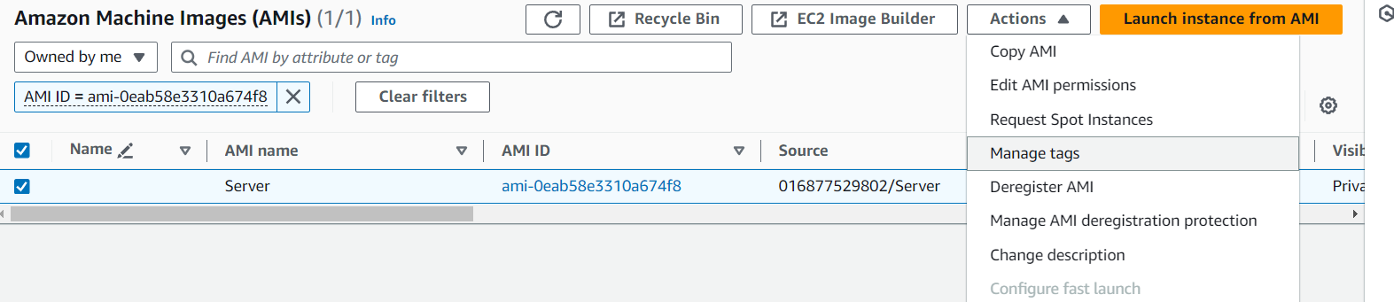

* + Right-click the AMI, select "Copy AMI," and choose US-West-2 (Oregon).

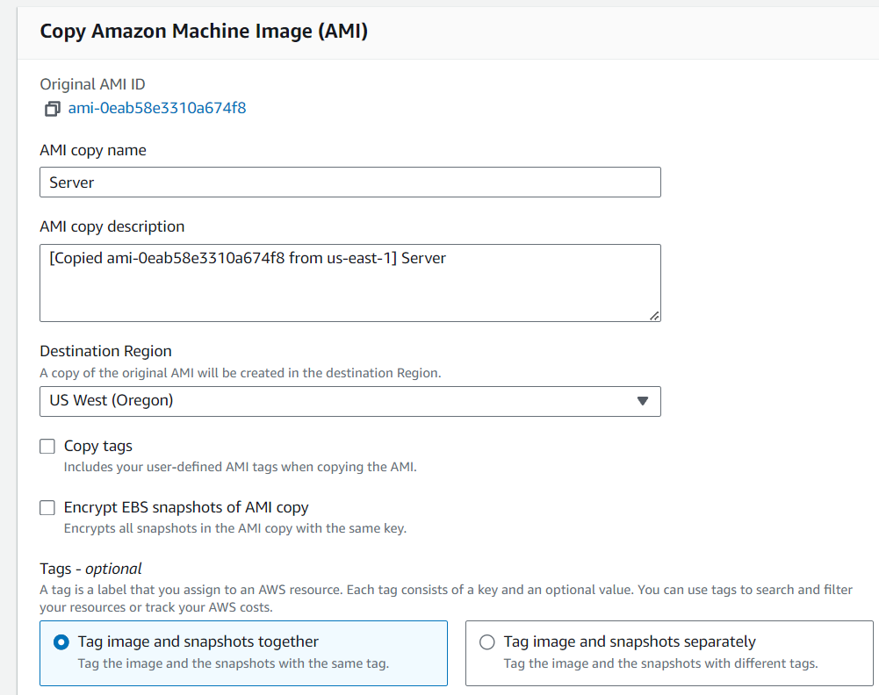

1. **Launch a New Instance:**
   * Once the AMI is copied to the US-West-2 region, navigate to the EC2 Dashboard in that region.
   * Launch a new instance using the copied AMI.

**Step 3: Create and Attach Two EBS Volumes in US-East-1**

1. **Create EBS Volumes:**
   * In the EC2 Dashboard for US-East-1, navigate to the "Volumes" section under "Elastic Block Store."
   * Click "Create Volume" and specify the size, type, and availability zone (make sure it matches your instance's availability zone).
   * Create two EBS volumes.
2. **Attach Volumes:**
   * After creation, right-click each volume and select "Attach Volume."
   * Attach both volumes to your EC2 instance.

**Step 4: Delete One Volume and Extend the Size of the Other**

1. **Detach and Delete a Volume:**
   * In the EC2 Dashboard, right-click the volume, select "Detach Volume," and then "Delete Volume."
2. **Extend the Remaining Volume:**
   * Right-click the remaining volume, select "Modify Volume," and specify the new size.
   * Confirm the modification.

**Step 5: Backup the EBS Volume**

1. **Create a Snapshot:**
   * Go to the "Volumes" section under "Elastic Block Store."
   * Right-click the volume you wish to back up and select "Create Snapshot."
   * Provide a name and description for the snapshot and click "Create Snapshot."